Evora user guide
Evora is an implementation of a board game Azul.
After starting the game, you are greeted with an intro screen where you can choose the players and start the game
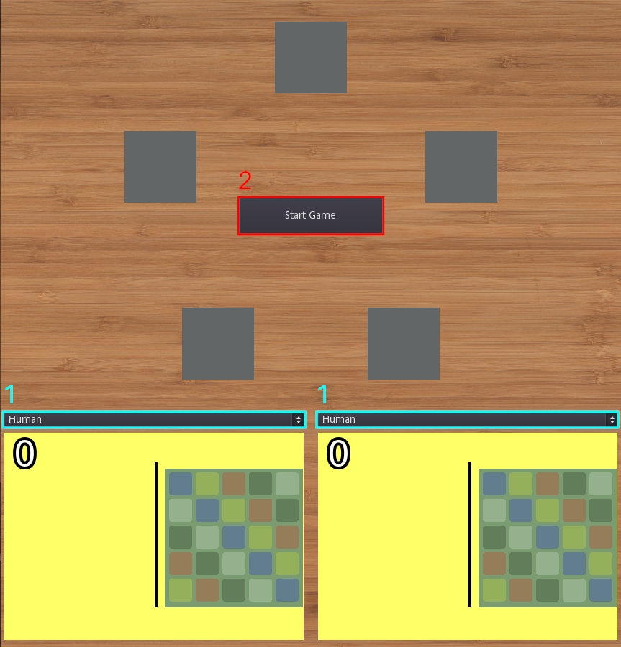
1. Player type selection
2. Start game button
After selecting the player types and starting the game you will be prompted to select a starting player which is done by clicking on the corresponding board, after which the game itself will start.
In the game itself you move the tiles by dragging and dropping. The rules for azul can be found here

